Assignment 3

1. ER diagram for Pre-owned dealer database

1. ER diagram for Assignment 1

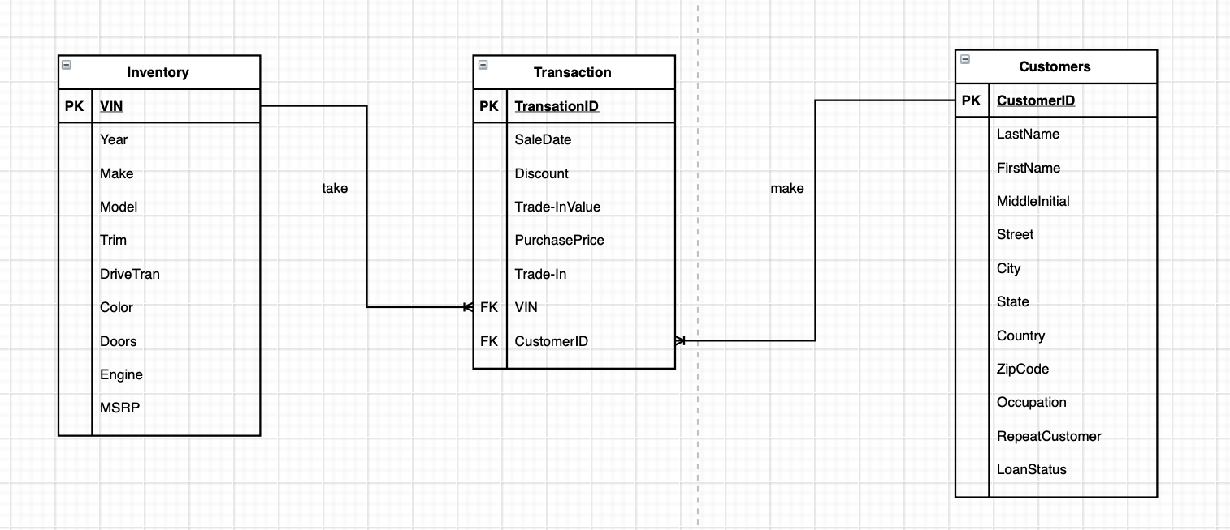

1. The following diagrams zoom in the modification part. Complete version is enclosed inside the zip file.

**Step 1: Create an entity called Associates**

* Create an Associate entity
* List the attributes for Associate entity such as name, phone number, address, etc.
* Rename the ASSOCIATE_NAME to AssociateID
* Tag AssociateID as foreign key

**Step 2: Combine the Customers Table of Part 1 and Part 2**

* Set CustomerID as primary key instead of TRANSACTION since one customer can have more than one transaction.
* Split the CUSTOMER_NAME into FirstName, MiddleInitial, and LastName
* Add phone attribute

**Step 3: Combine the Transactions Table of Part 1 and Part 2**

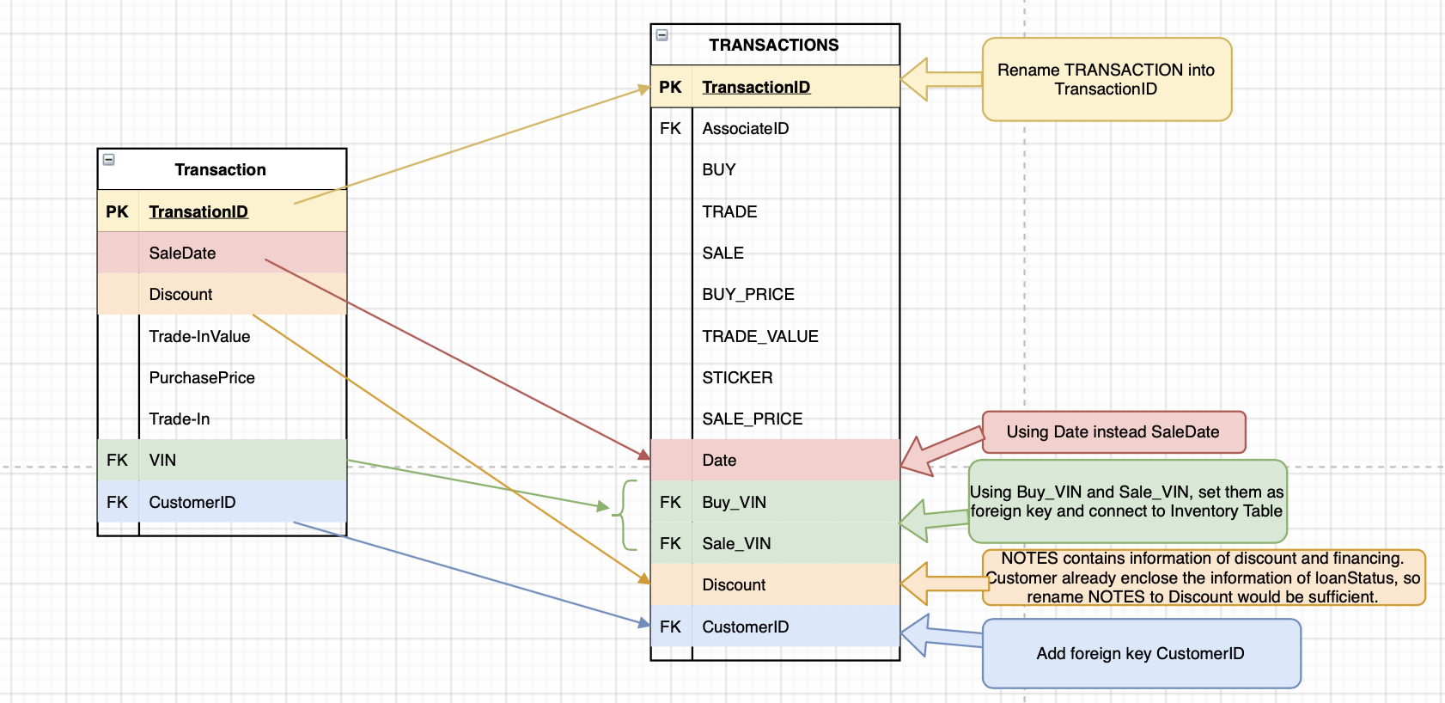

* Rename TRANSACTION to TransactionID
* Rename SaleDate to Date
* Separate VIN to Buy_VIN and Sale_VIN to distinguish new cars and pre-owned car
* Rename NOTES to discount. Originally NOTES contains information of financing and discount. Customer already have an attribute of loanStatus to store financing information. NOTES can store discount information only.
* Add foreign key CustomerID and connected with Customer entity

**Step 4: Modify Inventory**

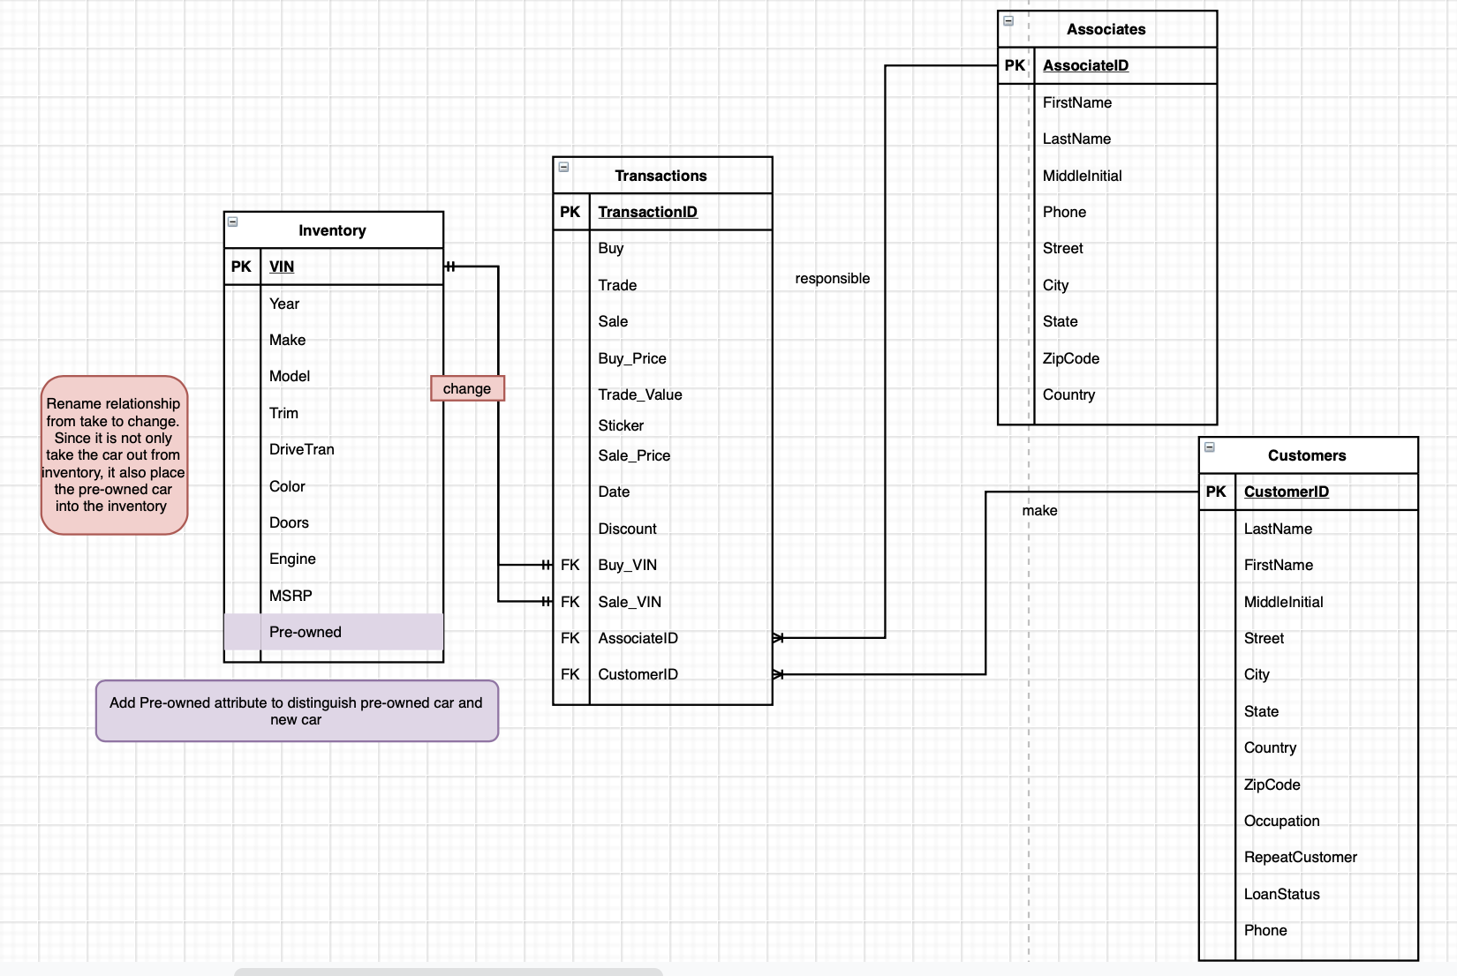

* Add Pre-owned attribute to Inventory entity
* Modify the relationship between Inventory and Transaction.

1. The final version of the schema

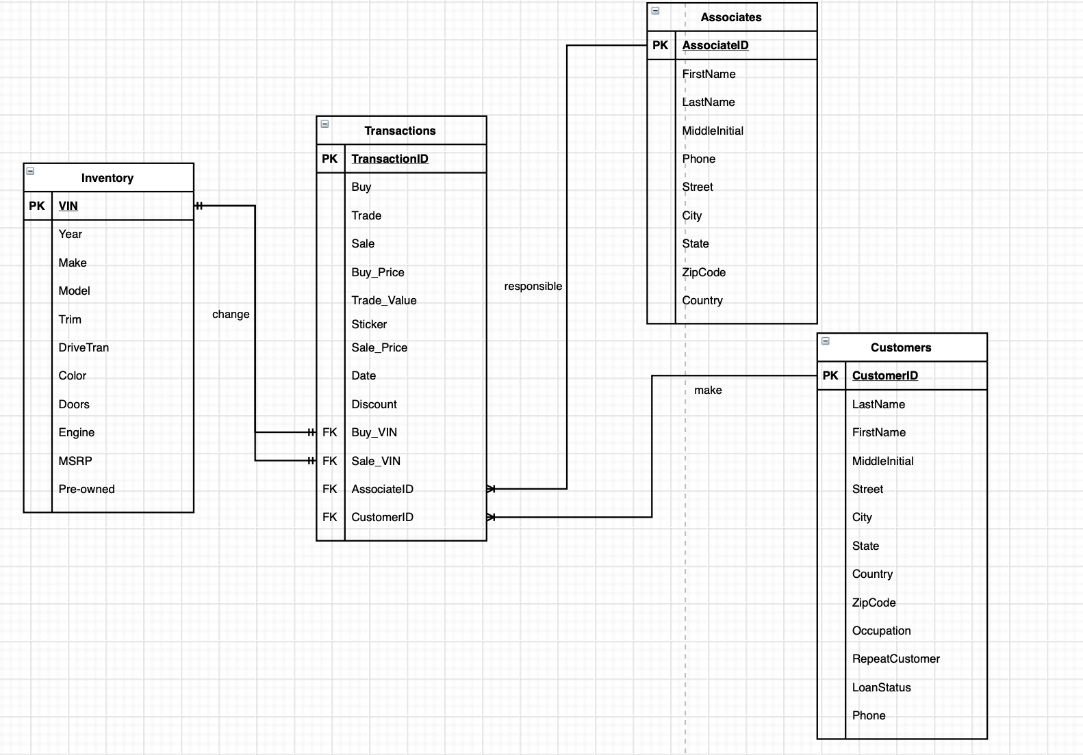

**Pros and Cons**

Pros

* During the integration process, all information has been retained
* Duplicates removed and renames fields that are easy to understand and self-explanatory
* Can be modified in the future

Cons

* The diagram can be cleaner. For example, create a Person entity that can store information and create keys for Associate entity and Customer entity
* Need to do more research on MSRP and stickers – they might be the same value
* Maybe increase more smaller table to store the value to increase data independence

**Curatorial Objectives**

* Storage
  + Can be stored in cloud storage or distributed file system which support reliable and effective storage.
* Preservation
  + Change of schema will be documented
* Discoverability
  + The system that stored the data would support text search and locate the place of the text.
* Access
  + The system that stored the data will support the access of data and distribution of data
* Integration
  + Can be integrated with other information such as Services and Car Accessories Inventory
* Sharing
  + The data can be access by different departments inside the dealership. For example, marketing can access the data and uses these data to provide better advisement.
* Communication
  + Since the schema is for auto dealership, it can create charts to provide visualization to shown which type of cars is the bestseller. Furthermore, it can set the price based on the popularity or determine future inventory.
* Modification
  + The schema will support updates and corrections. For example, inventory will mark out if the car is sold
* Compliance
  + Since the data contains the person information such as phone number and address, it will follow the requirements to handle personal information.
* Security
  + Data Flow Diagram would be drawn and uses necessary tools to protect the data and prevent it from tampering. For example, username and password would be needed for access and modify the database